
Operational Agility Software

Blue Prism Login Agent

Low Level Design

Revision History
Date | Revision | Author | Description
06/09/2012 | 1 | SW | Issued for Internal Review

The information contained in this document is the proprietary information of Blue Prism Limited and should not be disclosed to a third party without the written consent of an authorised Blue Prism representative.
© Blue Prism Limited, 2012

Contents
Revision History 2
Contents 3
Introduction 4
Requirements 5
Design 7
 Overview 7
 Components within the system account 7
 Components within the user account 8
 Components within the wider Blue Prism Environment 8
 Login Process 9
Product Information 11
 Deliverables 11
 Setup Required 11
 Tasks and Estimates 12

Introduction
Blue Prism is an operational agility platform which automates business processes. Typically, these processes are executed in a set of virtual machine environments with most manipulation of the behaviour occurring through the Blue Prism software and little to no direct user interaction.
User tasks which Blue Prism cannot currently automate include logging in and out of the windows operating system, and locking and unlocking the screen within the VM. This document gives a detailed technical description of a method of automating these functions and how they will operate within a wider environment.

Requirements
The detailed requirements have been inferred from a number of sources:-
- "Windows API, Desktop Authentication and vSphere controls", issued by Elliot Smith on 20/08/2012
- Barclays Symphony Environment Solution Design Document, issued by Denis Dennehy on 20/08/2012
- Subsequent discussions with stakeholders
Note that the IDs assigned to requirements here are meaningful only within the scope of this document to enable straightforward referrals to requirements in later sections
ID | Narrative
1 | A mechanism must be available to enable a VM hosting a Blue Prism resource to be logged into without direct manual intervention.
2 | The mechanism described in [1] must be able to be run by a user from within a Blue Prism client within the same Blue Prism environment.
3 | The mechanism described in [1] must be able to be run by an active Blue Prism Scheduler instance within the same Blue Prism environment.
4 | A mechanism must be available to enable a VM hosting a Blue Prism resource to be logged out without direct manual intervention.
5 | The mechanism described in [4] must be able to be run by a user from within a Blue Prism client within the same Blue Prism environment.
6 | The mechanism described in [4] must be able to be run by an active Blue Prism Scheduler instance within the same Blue Prism environment.
7 | The mechanism described in [4] must be able to be run from within a session executing within the target VM.
8 | A mechanism must be available to enable a VM hosting a Blue Prism resource to be unlocked without direct manual intervention.
9 | The mechanism described in [8] must be able to be from within a session executing within the target VM.
10 | A mechanism must be available to enable a VM hosting a Blue Prism resource to be locked without direct manual intervention.
11 | The mechanism described in [10] must be able to be from within a session executing within the target VM.
12 | A mechanism must exist to enable the operating system password for the Blue Prism user to be updated without direct manual intervention.
13 | The mechanism described in [12] must be able to be run by a user from within a Blue Prism client within the same Blue Prism environment.
14 | The mechanism described in [12] must be able to be run by an active Blue Prism Scheduler instance within the same Blue Prism environment.
15 | The credentials used to log in and unlock the VM must be encrypted using the BCAG (which I don't know what it stands for) appliance

Design

Overview
Due to the nature of the requirements, a component will need to be installed which operates outside of any Windows user account - i.e. at system account level. This will provide the access required to enable automatic login without user interaction.
The mechanism which retrieves the credentials must be available both from the user account and from the system account so that sessions running in the user account can unlock the VM and sessions created on the system account can log into the operating system.

Components within the system account
Three components run within the system account. This means that they can run while the VM is logged out, but do not have access to user programs or the desktop.

Blue Prism Credential Provider DLL
Microsoft provides an API to enable credentials to be provided to a Windows system. This is called the 'Credential Provider' API - it is used by installing a DLL into the System32 directory and registering it with Windows within the registry.
The Blue Prism implementation of the credential provider will create a named pipe server which can only be connected to on the local machine. This reads and parses login requests from the named pipe, taking the given credentials and attempting to authenticate to Windows with them.
This DLL has no awareness of the wider context - e.g. Blue Prism instances, BCAG, etc. It takes a login request, extracts the credentials from it, attempts to authenticate to Windows and returns a success / failure response to the client which sent the request.

Blue Prism Login Agent Service
A windows service running under the local account will execute when the VM starts up and stay running until the VM is shut down. This monitors the logged in state of the VM and ensures that a Blue Prism Resource is running in the system account while the VM is logged out.

System Account Resource PC
A Blue Prism resource is executed and maintained by the Login Agent Service. This resource runs within the system account and so does not have access to user account programs. It is not expected to run any processes other than a bespoke 'Login Process' which will instruct the resource to log into the VM by retrieving credentials from the server and passing them via the Credential Provider DLL into Windows.
On a successful login, the system account resource is shut down to make way for the resource which will run in the user account. It is started again when the VM is logged out. The Login Agent service is responsible for detecting the state of the VM and ensuring that the system account resource is running or not as appropriate.

Components within the user account
After login, control switches largely to the user account. The service continues to run but is largely dormant until it detects that the VM is logged out. The credential provider DLL is still loaded and is still available for locking and unlocking the screen.

User Account Resource PC
The VM is configured to start a resource PC on login to Windows. This operates within the user account and thus has full access to the desktop and all programs available to the logged in user.
This resource will continue to run until requested to log out of Windows. It can lock and unlock the VM desktop within any of its hosted processes by calling actions on the Login Agent VBO.
A 'Logout Process' can be run on this resource which will close all running user programs (including the resource) and log out of the VM. Any running sessions will be terminated on logout.

Login Agent VBO
A VBO (Visual Business Object) is available for processes running on this resource which will allow the VM to be locked or unlocked by communicating with the Credential Provider DLL running under the system account.

Components within the wider Blue Prism Environment
The credentials to use for a VM to log into windows are held in the Blue Prism credential store, having been encrypted first using the BCAG service.

Login Process

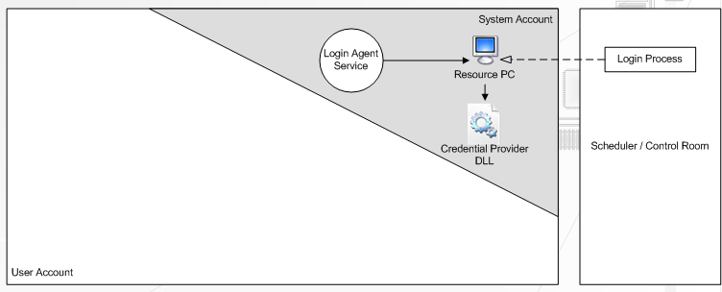
Before Login

Figure 1 - Before Login
On boot, the login agent service starts and runs a Resource PC in the system account. This has no access to user programs.
Either from the scheduler or Control Room within a Blue Prism client, a 'Login Process' is created and run on the resource PC. This connects to the credential provider with retrieved login credentials and logs into Windows.

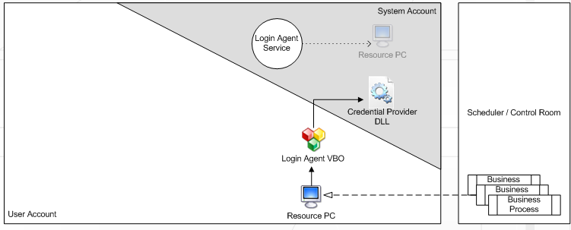
After Login

Figure 2 - After Login
After a successful login, the system account resource PC is closed. The VM is configured to start a resource PC on login - this will operated within the user account and so will have access to the desktop and user programs to be automated. Sessions can be created and executed on it in the usual manner.
The 'Login Agent' VBO is available to enable the VM's screen to be locked and unlocked using the stored login credentials.

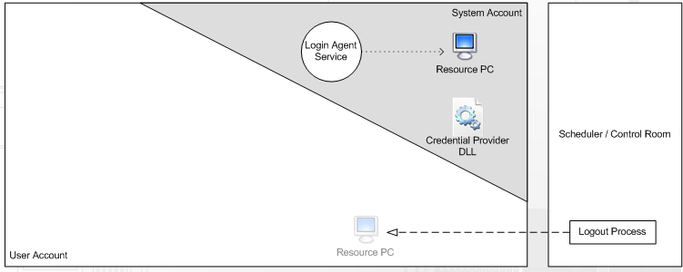
Logging Out

Figure 3 - Logging Out
A "Logout Process" is created and run on the user account resource PC while the VM is still logged in. This process will instruct Windows to log out. In doing so, the resource PC is closed down with all other user account applications.
The Login Agent service detects that the user has logged out and starts the resource PC in the system account to await the login process instructing the VM to login once more.

Product Information

Deliverables
The new components which will be required in order to implement the Login Agent on a VM are as follows:-
- Credential Provider DLL
- Login Agent Service Executable
- Login Agent VBO
- Login Process (which largely delegates to the Login Agent VBO)
- Logout Process (which largely delegates to the Login Agent VBO)
- A version of Blue Prism v4.1, patched to enable the shutting down of a resource PC after successful execution of the login process.

Setup Required
A small amount of configuration will be required for a VM to be able to support the Login Agent. These steps must be performed on each VM unless otherwise stated.
- Installation of the Credential Provider DLL into the System32 folder
- Installation and configuration of the Login Agent service
- Importing of a Blue Prism release containing the Login Agent VBO and the Login and Logout processes (once per Blue Prism environment).
- Installation of a new version of the Blue Prism software.
- Merging of a registry file which registers the credential provider DLL with Windows.
- Enable the 'Disable CTRL + ALT + DEL requirement for log' security policy. This is found in the local policy path:
Computer Configuration\Windows Settings\Security Settings\Local Policies\Security Options

Tasks and Estimates
The following development tasks have been identified for this project. Estimates are for development team time only.
- Design - 2 days
- Credential Provider DLL - 2 days
- Login Agent Service - 2 days
- Login Agent VBO / Processes - 6 days
- Product Changes - 4 days
- Testing - 4 days
- Product Release - 1 day
Total Estimate: 21 days.

